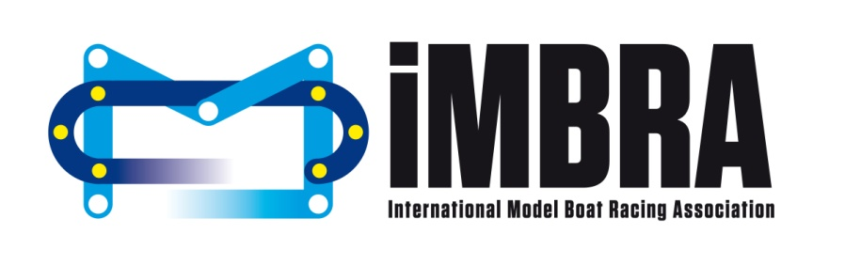

Official Invitation to the iMBRA World Championship 2018

We are pleased to invite you to the second official IMBRA World Championship which will be held in Egletons, France, fromJuly30thto August 11th2018.
Event Location:
Lac du Deiro
Egletons
France

The event is being hosted by the Fédération de France de Modélisme Naval and will be run in conjunction with the iMBRA committee and volunteers from a number of our member countries. We would like to thank the town’s mayor, Charles FERRE and all the city council from this lovely village of Egletons for their support and assistance in the preparation of the event.
Our aim is to host a professional and friendly event that brings countries together to enjoy top class racing throughout the Endurance, Hydro & Offshore classes.
The Team Leader/Official Representative from each country must ensure the attached entry forms are fully completed and returned by the 31st May 2018. All forms must be submitted either via email to wcimbra2018@gmail.com or via post to:
Erich COSTA
86 rue Aristide Briand
91230 MONTGERON
FRANCE

Costs for the World Championship are as follows:
Entry fee per class:
Juniors - 20 Euro
Seniors - 35 Euro
Camping per night:
20 Euro per night.
The campsite is situated around the lake; the northern area of the racing lake (Moulin de Boule) and will be laid out in squares. Each square will provide enough room for a caravan and car, tent and car or a camper van. Each square costs 20 euro per night.
The camping will be open from 1p.m. on Saturday 28th July 2018 and everybody must depart no later than Sunday 12th August 2018 at 1p.m.
There is a small campsite located nearby for people wishing to arrive earlier or stay longer after the event. The location is:
Camping Egletons-Lac
10 Le Pont
19300 Egletons
FRANCE

Shops and Trailers to be situated down by the race lake:
Shops - 100 Euro per week (day rate is not available)
Trailer - 50 Euro per week (It is not possible to move the trailer from the race lake on a daily basis. The trailer will need to remain in place for the duration of the event/week as required)

Banquet per person:
18 Euro per person
12 Euro for children aged 6 - 12
Free for children under the age of 5
Free entry for anybody attending but not eating

The banquet will be held on Saturday the 4th August following the O & H finals and prize giving.

Payment details:
Please make all payments directly to:
AccountName: Motonautisme de Nanterre
AccountAddress: 4 B rue du pont Colbert, 78000 Versailles, France

Bank Name:Société Générale
Bank Address: Versailles Porchefontaine, France
IBAN : FR76 3000 3022 0200 0503 0204 462
BIC : SOGEFRPP

All funds (entry fee, camping, banquet, shop, and trailer) must be received by 31st May 2018 at the latest. A confirmation email will be sent upon receipt.

Team Leaders:
Please ensure that the team leader’s name, phone number and email address are provided when submitting the entry forms.

Additional Information:
Please see attached the provisional timetable. The date of trainings, finals and the banquet will not change. The number of classes per day will be dependent on the confirmed number of entries.
Training Lake - the lake situated adjacent to the race lake and next to the Ibis hotel will be used as the training lake. The lake will be open for training as it is on the timetable. Training will also be available on the main race lake, see timetable.
For information on the location of the World Championships along with local hotels and things to do in the area please visit the IMBRA website https://www.imbra-racing.com/
We look forward to seeing you all at the event and if anybody has any questions or would like to get involved in any way (no matter how big or small) please do not hesitate to get in touch.

Kind regards
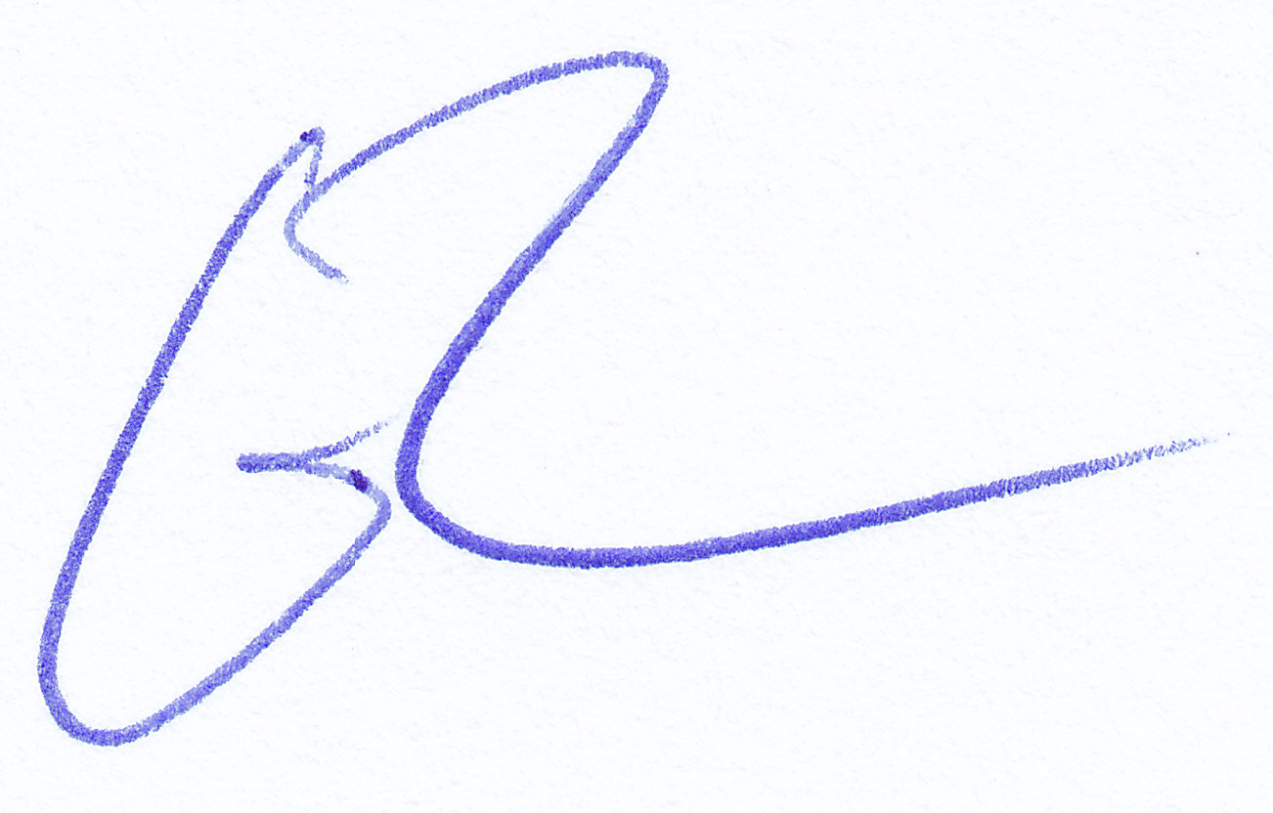
Lauren Morrison & Erich Costa
on behalf of the IMBRA Committee

